80 days to overcome IELTS Writing (Second Edition)

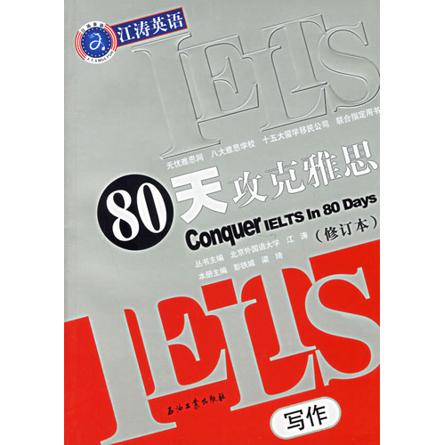
Introduction before you begin to write the essay volumes of this book, students actually need to fill what is the problem, our authors have been constantly an issue to discuss or even debate. According to the traditional thinking to explore, only a dead end! IELTS essay book has been focused to provide students with a lot of writing templates and writing Pham Van, but in fact came from the British Council, the standard interest rate on the writing score is blocking the death IELTS score of the students are mostly speculative - Once suspected of copying all kinds of writing in their writing a low score or a zero.
The largest point of the book is that it breaks for the candidates to the old routine of writing templates and writing Pham Van, exhorted the students writing ideas should be derived from their own lives and real feelings, to make the essay highlights the innovative. Book from these three aspects of the discourse text, letters, charts, writing, and the means to explain the increase practice their writing innovation, fundamentally changed the status of most of the candidates writing low score.

